17/02/2026
Lab 2 – Queries
1.
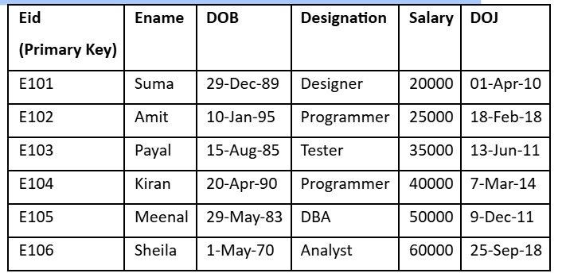
Perform the following operations
Display the details of the employees whose name contains ‘ee’.
Display the salaries of employees by 5000 whose designation is DBA.
Display the employees whose salary is more than the average salary of all the employees.
Display the record in the following format: xxxxxxxxx is working as xxxxxxxxxxxxxx with a Salary ofRs.xxxxxxxx
eg: Suma is working as Designer with a Salary of Rs. 20000

Sol:
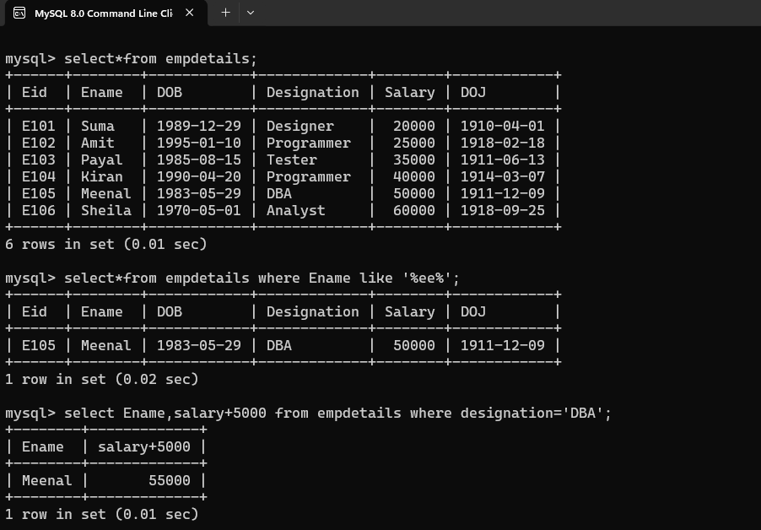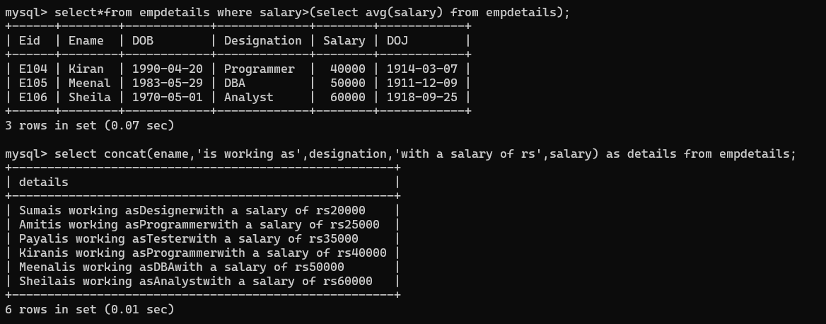

2. Write a query to display all the employees working in ‘XYZ’ company Create a Table as Company and the details are
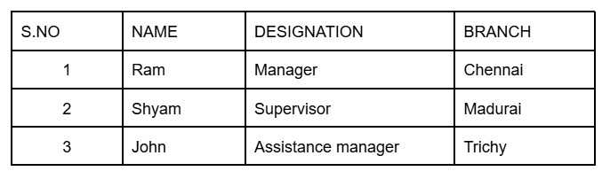

Perform the following:
Alter the table by adding a column Incentives
Alter the table by modifying the column Branch
Describe the table
Delete any 2 rows from the table
Drop the table
Define Grant and Revoke

Sol:
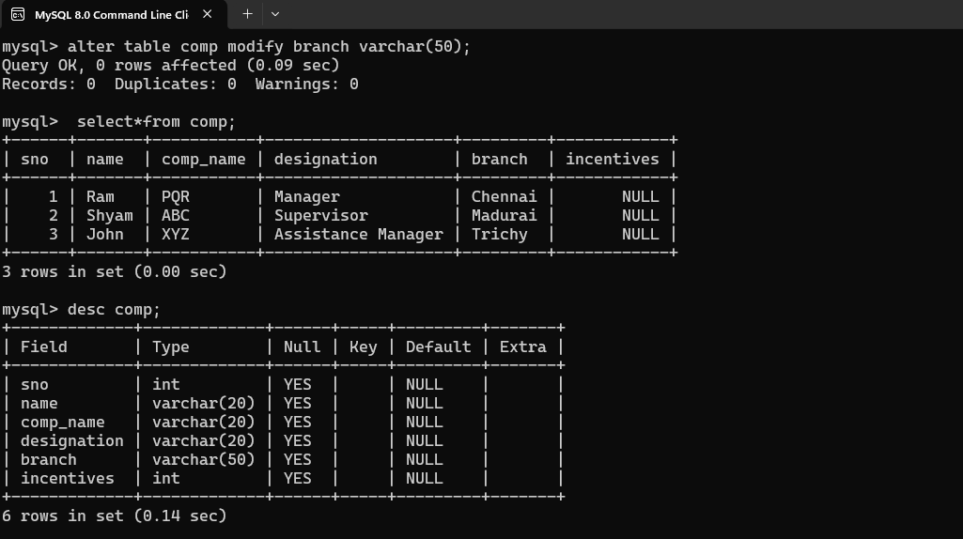
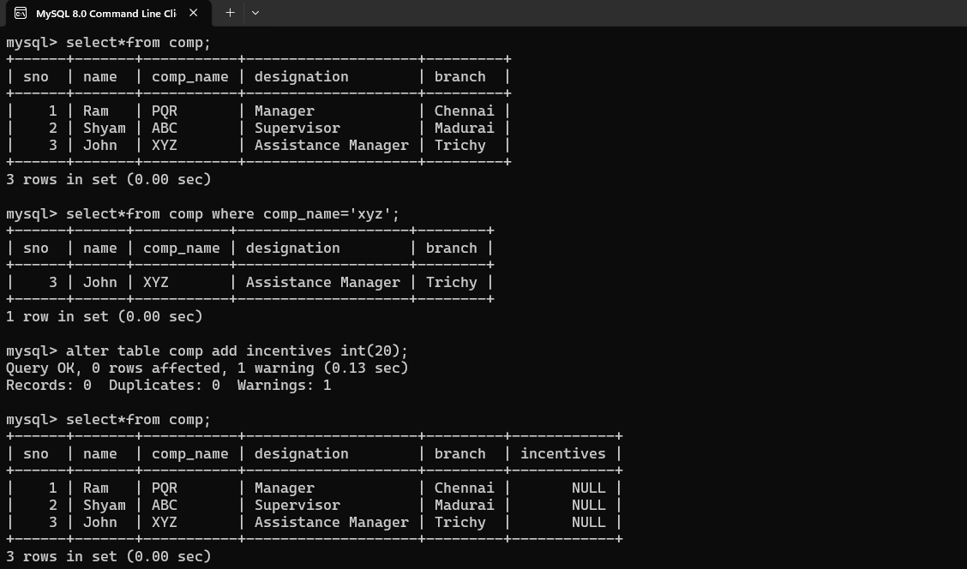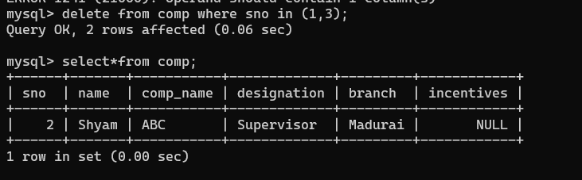

3. 1. Consider the following schema. Employee(Emp_no, Name, Emp_city).Company (Emp_no, Company_name, Salary).
Create a table
Insert 5 rows for each table
Write SQL Query to display Employee Name and Company Name
Write SQL Query to display Employee name, employee city, company name and salary of all employees whose salary is greater than 10000

Sol:
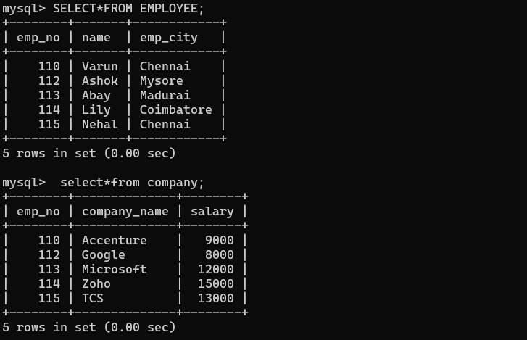
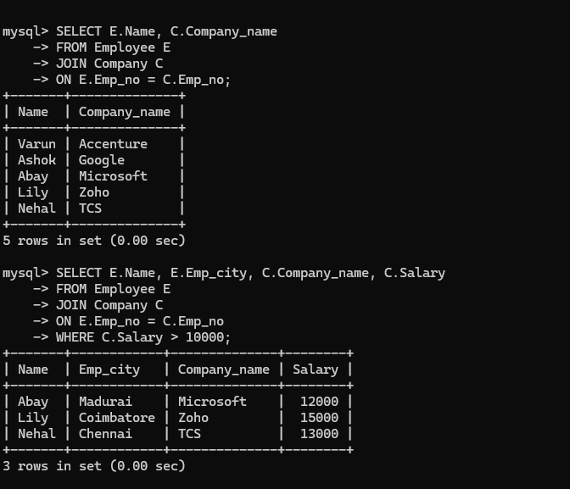

4. Create a table Student_Result with the details given below
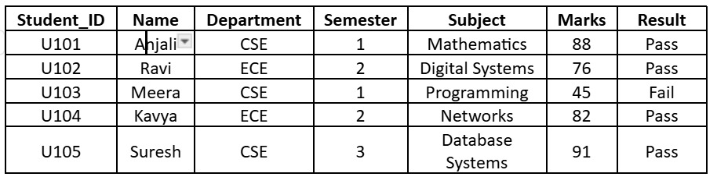
Perform the following operations
Display the Student_ID, Name, Semester, Subject and Marks of students who belong to either CSE or ECE department from the Student_Result table.
Display the Student_ID, Name, Department, Semester, and Marks of students whose name starts with the letter 'A' .
Display the Student_ID, Name, Department, Subject, and Marks of students who scored between 60 and 90 marks.
Sol: 